21.65:
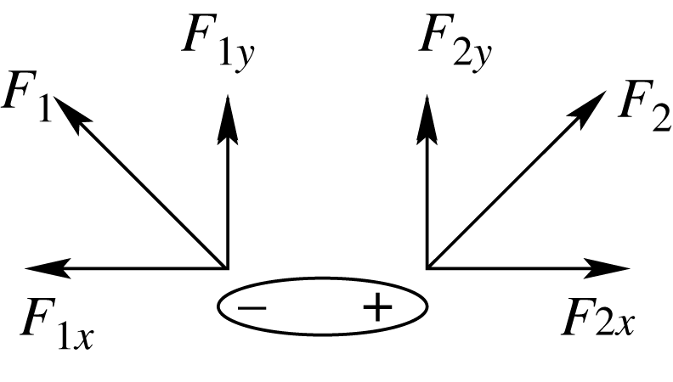 The dipoles attract.
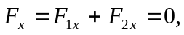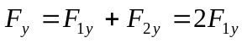

b)
Opposite charges are closest so the dipoles attract.

